Terraform code for VPC and all components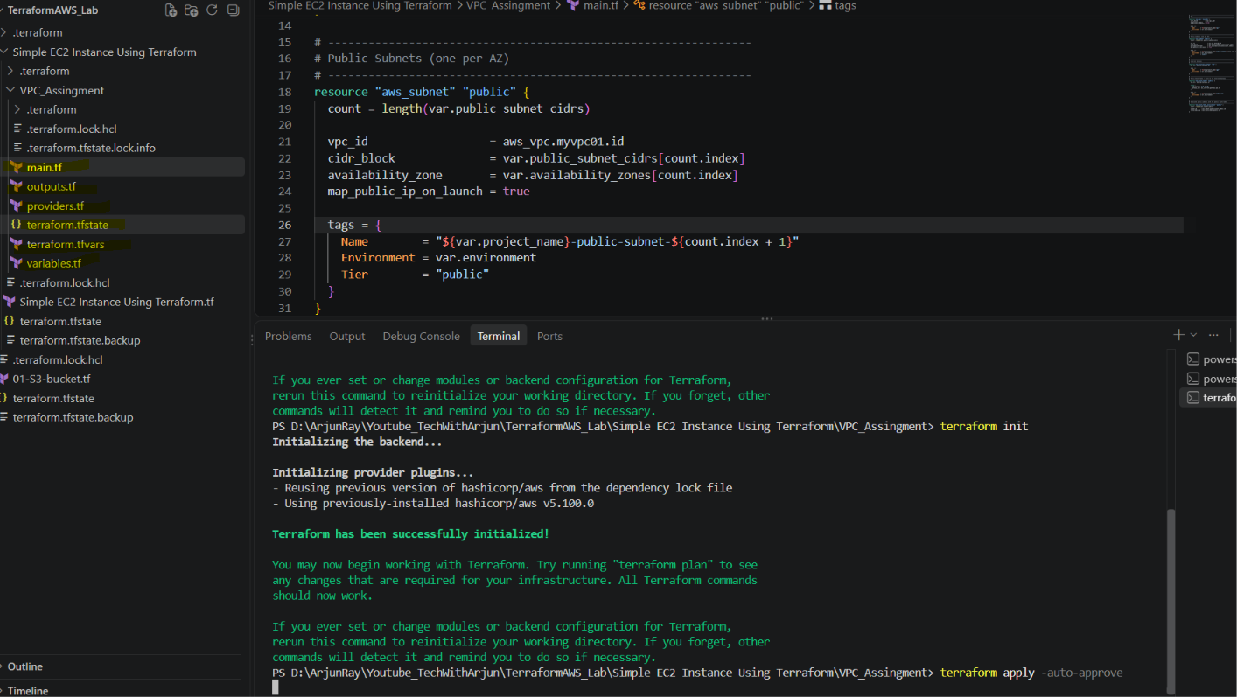
Main.tf
# ---------------------------------------------------------------
# VPC
# ---------------------------------------------------------------
resource "aws_vpc" "myvpc01" {
cidr_block = var.vpc_cidr
enable_dns_support = true
enable_dns_hostnames = true

tags = {
Name = "${var.project_name}-vpc"
Environment = var.environment
}
}

# ---------------------------------------------------------------
# Public Subnets (one per AZ)
# ---------------------------------------------------------------
resource "aws_subnet" "public" {
count = length(var.public_subnet_cidrs)

vpc_id = aws_vpc.myvpc01.id
cidr_block = var.public_subnet_cidrs[count.index]
availability_zone = var.availability_zones[count.index]
map_public_ip_on_launch = true

tags = {
Name = "${var.project_name}-public-subnet-${count.index + 1}"
Environment = var.environment
Tier = "public"
}
}

# ---------------------------------------------------------------
# Internet Gateway
# ---------------------------------------------------------------
resource "aws_internet_gateway" "igw" {
vpc_id = aws_vpc.myvpc01.id

tags = {
Name = "${var.project_name}-igw"
Environment = var.environment
}
}

# ---------------------------------------------------------------
# Public Route Table + route to the Internet Gateway
# ---------------------------------------------------------------
resource "aws_route_table" "public" {
vpc_id = aws_vpc.myvpc01.id

route {
cidr_block = "0.0.0.0/0"
gateway_id = aws_internet_gateway.igw.id
}

tags = {
Name = "${var.project_name}-public-rt"
Environment = var.environment
}
}

# ---------------------------------------------------------------
# Associate public subnets with the public route table
# ---------------------------------------------------------------
resource "aws_route_table_association" "public" {
count = length(aws_subnet.public)

subnet_id = aws_subnet.public[count.index].id
route_table_id = aws_route_table.public.id
}

Deployment completed successfully.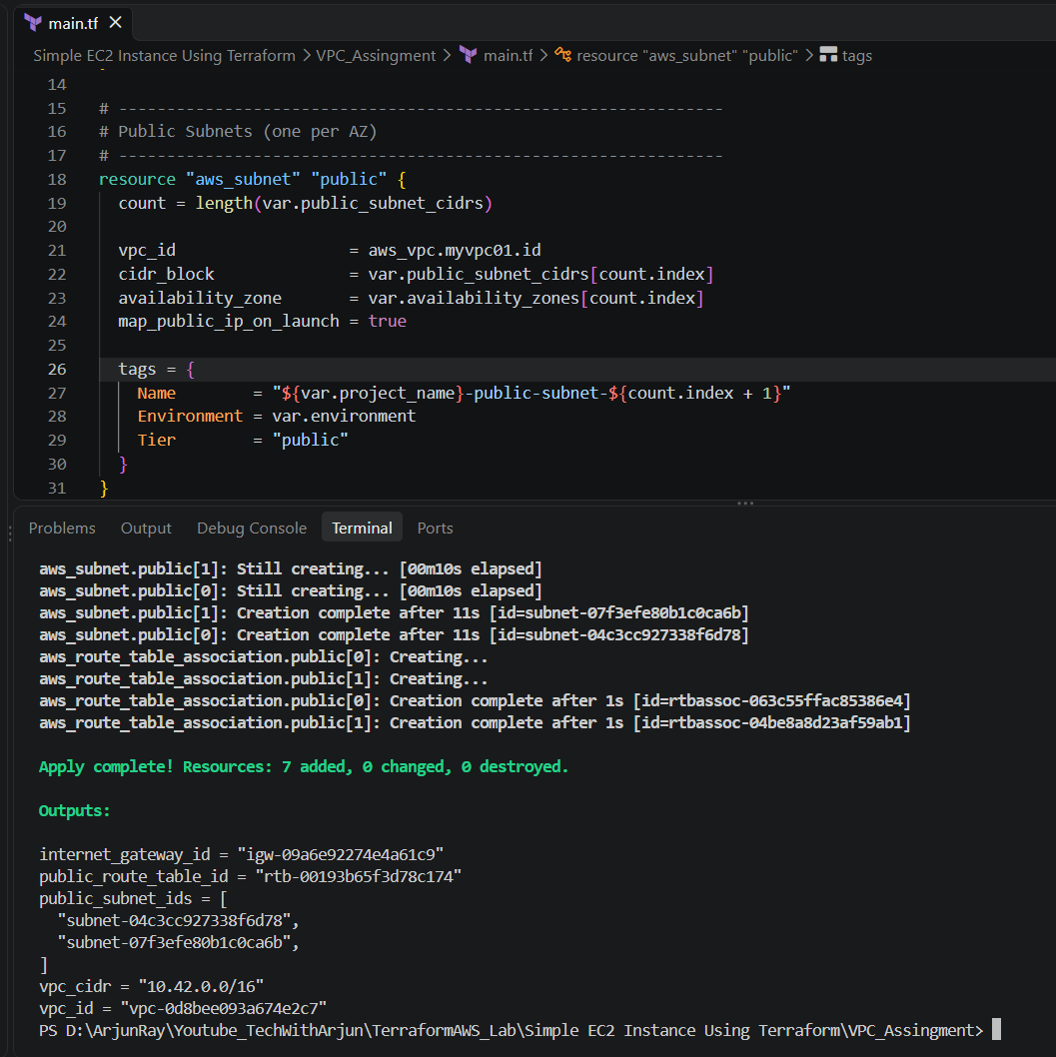

Validation from console.
